**MODBUS RTU SETUP FOR TDS V8 DRIVES**

1. **Enable Modbus RTU as the Command Source**

**For the inverter to accept run commands and frequency references via Modbus, you must set the command sources to the RS-485 port.**

**FOR VFD CONTROL:**

Parameter Sn-04: Run Source selection

Default Value: 0 or 1 (Typically Keypad or Control Terminals)

Required Value: 2 (Operation Command comes from RS-485 port)

Parameter Sn-05: Frequency Command selection

Default Value: 0 or 1 (Typically Keypad or Control Terminals)

Required Value: 2 (Frequency Command comes from RS-485 port)

**2. Set the Communication Parameters**

**These parameters define the physical layer of the Modbus network.**

Parameter Sn-36: Inverter Address

Default Value: 1

**Required Value: 1 (This is the requested slave address. The range is 1-31).**

Parameter Sn-37: RS-485 communication baud rate setting

Default Value: 3 (9600 bps)

**Required Value: 3 (9600 bps)**

*Note: The numerical values correspond to: 0=1200, 1=2400, 2=4800, 3=9600.*

Parameter Sn-38: RS-485 communication transmission parity setting

Default Value: 0 (No Parity)

**Required Value: 0 (No Parity)**

Note: This setting, combined with the default stop bits, creates the 8N1 format. The manual states that with no parity, the character frame has one stop bit.

WARNING: The manual specifies that after changing Sn-37 or Sn-38, the inverter must be **POWERED OFF** and then **BACK ON** for the new settings **TO TAKE EFFECT**.

**3. (Optional) Configure Communication Fault Behavior**

**Set how the drive reacts if the Modbus communication fails.**

Parameter Cn-27: Communication Fault Detection Time

Default Value: 01.0 seconds

Description: This defines how long the drive waits without a valid message before triggering a communication fault/alarm. If set to 00.0, fault detection is disabled.

Parameter Sn-39: RS-485 communication Fault stop selection

Default Value: 0 (decelerate to stop according to parameter bn-02)

Description: Defines the stopping method if a communication fault (CE-r) is detected. Other options are free-run stop, fast deceleration, or continue running.

Verification of Communication

After wiring the RS-485 cables to terminals S(+) and S(-) and configuring the parameters:

Power Cycle: Ensure you power the inverter off and on again to activate the new communication settings (Sn-37, Sn-38).

Check Standby Status: If the parameters are set correctly and the drive is in STOP mode but not receiving data, the digital controller will display "CE-r" blinking. This indicates it is correctly configured and in standby, waiting for a command from the Modbus master.

Test with Modbus Software: Use a Modbus master tool (e.g., ModScan, Simply Modbus) to read a well-known register.

Example Test: Read the Output Frequency from monitor register 0025H.

Master Query (Read): 01 03 00 25 00 01 [CRC16]

A valid response from the inverter (e.g., containing a frequency value) confirms the slave address, baud rate, and data format are correct. The blinking "CE-r" display should stop once communication is established.

**HIGHLIGHTED ARE THE PARAMETERS THAT SHOULD BE CONFIGURE FOR “VFD CONTROL” IF MONITORING PURPOSE ONLY THEN SKIP THAT PARAMETERS**

|  |  |  |  |  |
| --- | --- | --- | --- | --- |
| Parameter | Name | Default Value | Required Value | Description |
| Sn-36 | Inverter Address | 1 | 1 (or desired 1-31) | Sets the Modbus slave address. |
| Sn-37 | Baud Rate | 3 (9600 bps) | 3 (9600 bps) | 0=1200, 1=2400, 2=4800, 3=9600 |
| Sn-38 | Parity | 0 (No Parity) | 0 (No Parity) | 0=No Parity (8N1), 1=Even, 2=Odd |
| Sn-04 | Run Source | 0 (Keypad) | 2 | Set to 2 for commands from RS-485. |
| Sn-05 | Frequency Command | 0 (Keypad) | 2 | Set to 2 for reference from RS-485. |
| Cn-27 | Comm Fault Time | 1.0s | Set as needed | Time before CE-r fault on comms loss. 00.0=Disabled. |
| Sn-39 | Fault Stop Method | 0 | Set as needed | Defines inverter behavior on comms fault (CE-r). |

**RS485 Wiring Setup**

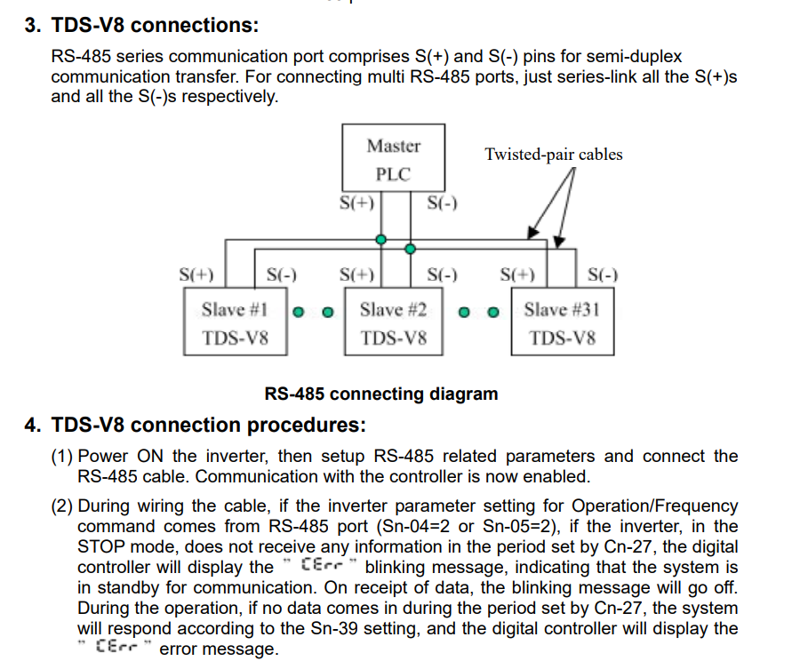

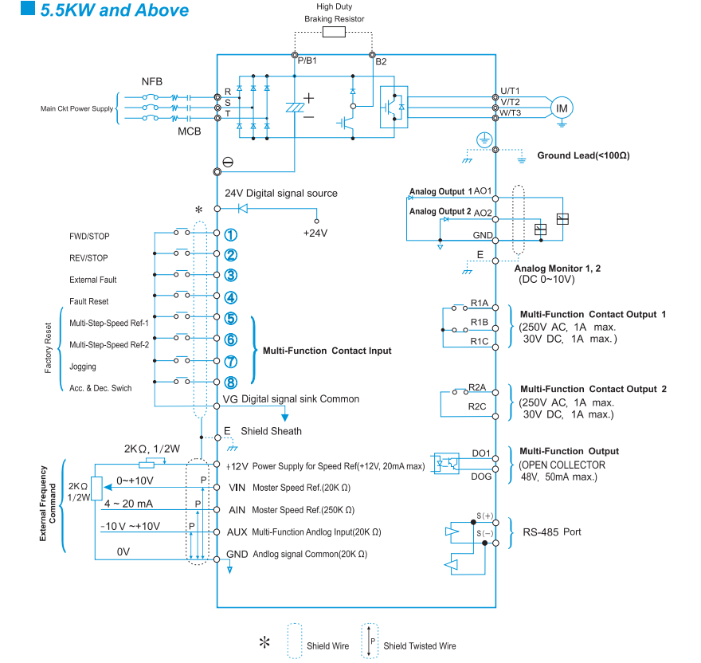

**NO BUILT IN TERMINATION MUST USE 120 OHMS FOR BOTH ENDS**